Heuristic Report

# Heuristic Descriptions

I will start by going through the three heuristics I created, and describing how they work from a high level:

* Custom_Score is a copy cat strategy, trying as hard as it can to do what the other player did their previous move
* Custom_Score_2 can be described as an extended AB_improved
* Custom_Score_3 can be described as a modified AB_improved

## Custom_Score Description

Custom_Score is a copy cat strategy:

It is incredibly simple: it will try to place pieces as close to where the other player placed their piece last turn.

## Custom_Score_2 Description

Custom_Score_2 can be described as an extended AB_improved:

* Custom_Score_2 calculates the difference between it’s moves, and its opponents moves the same way that AB_Improved does,
  + If Custom_Score_2 is ahead of the opponent, it will try to place pieces as close to the bottom right corner as possible
  + Otherwise, if Custom_Score_2 is behind, it will play the same AB_Improved
* The thinking behind Custom_Score_2’s strategy, is that if placing pieces in the bottom right corner is outperforming AB_Improved, then it will continue to keep placing pieces in the bottom right corner, which should lead to it winning,
  + If placing pieces in the bottom right, isn’t working, then it will revert to the same strategy as AB_Improved, which should give it a chance to win a game it is falling behind in

## Custom_Score_3 Description

Custom_Score_3 can be described as a modified AB_Improved:

* It uses two parts to calculate utility:
  + Part 1: the difference between players and the opponents moves
  + Part 2: the distance between the player and the opponent, the player is incentivized to try to get away from the other player
* These two parts are added together and returned to drive the agents behaviour

# Heuristic Performance

## Custom_Score Performance

Each table was created running tournament.py with 500 matches (1000 games total). The Custom_Score heuristic doesn’t tend to do very well against the majority of example player.

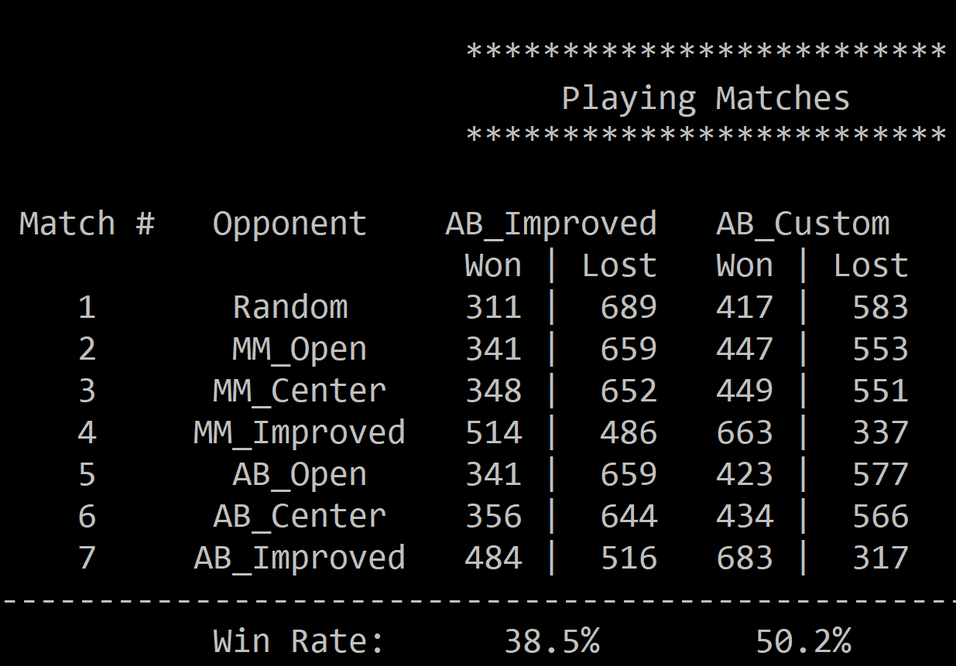

However, Custom_Score does very well against AB_Improved, winning roughly 2/3’s of the games when it plays 500 matches again AB_Improved. For this reason I chose Custom_Score as the best heuristic of the three I created.

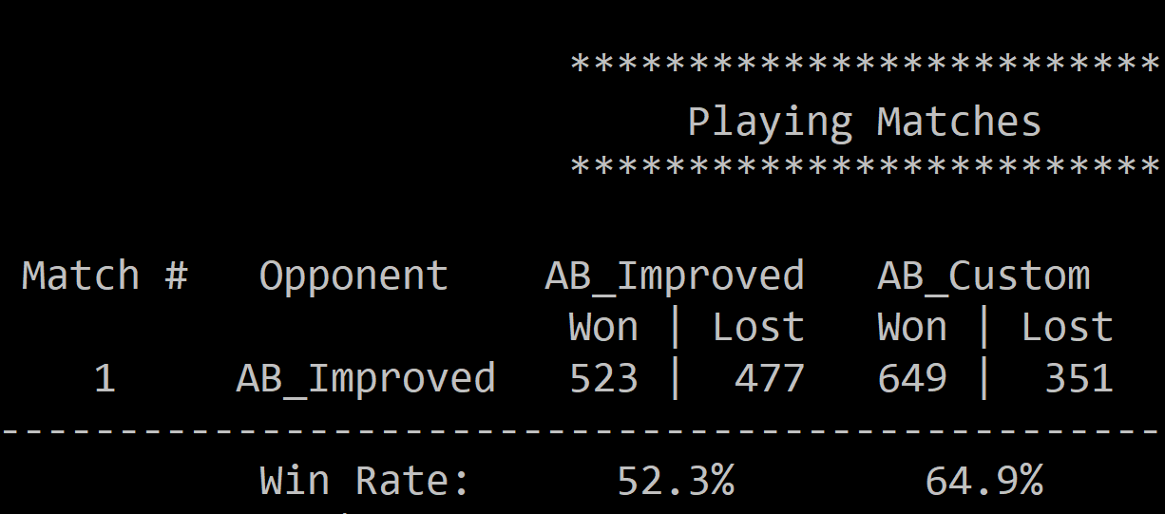

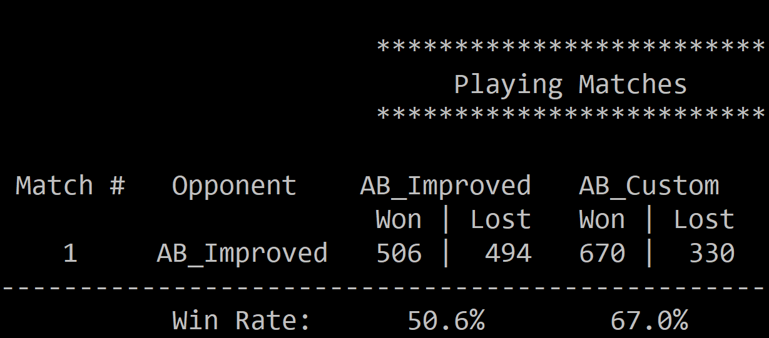

Why does Custom_Score do so well against AB_Improved:

**( I DON’T KNOW )**

For these reason I think Custom_Score is the heuristic that should be choosen.

## Custom_Score_2 Performance

From all my tests, it looks as though Custom_Score_2 is always close to having a 50%-win rate against the 7 example agents, but never manages to get above 50%.

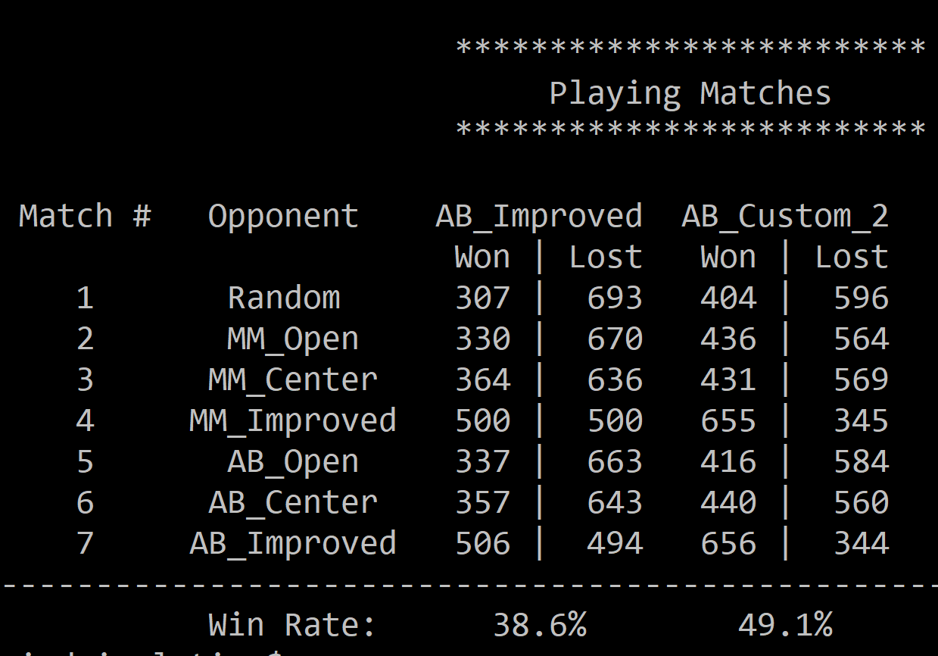

Custom_Score_2 performs similarly against AB_Improved, winning roughly 2/3 of games. However it does perform slightly worse than Custom_Score.

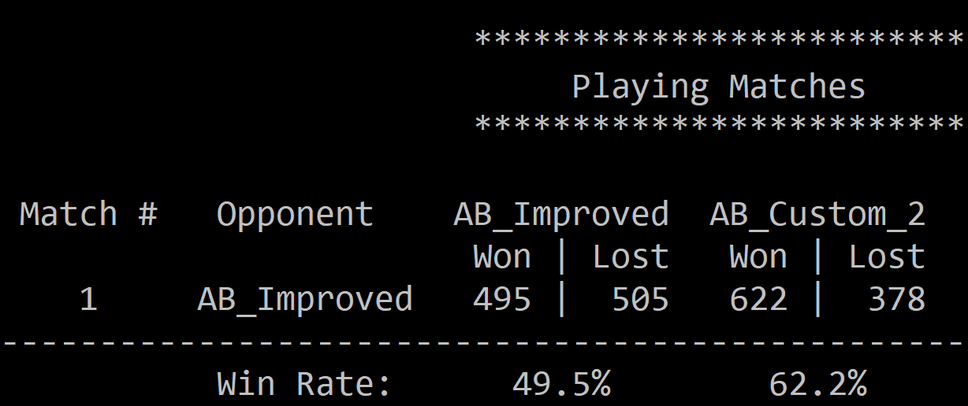

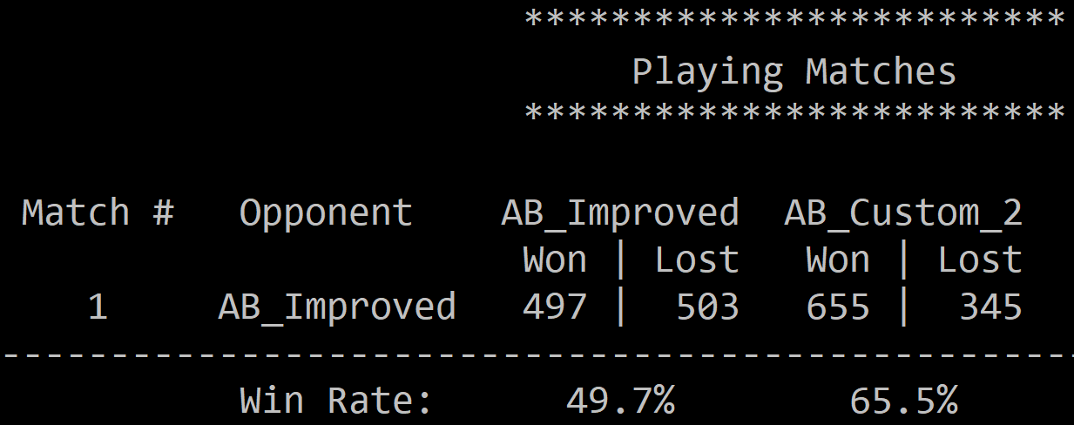

## Custom_Score_3 Performance

Custom_Score_3 does the worst against the other 7 test agents.

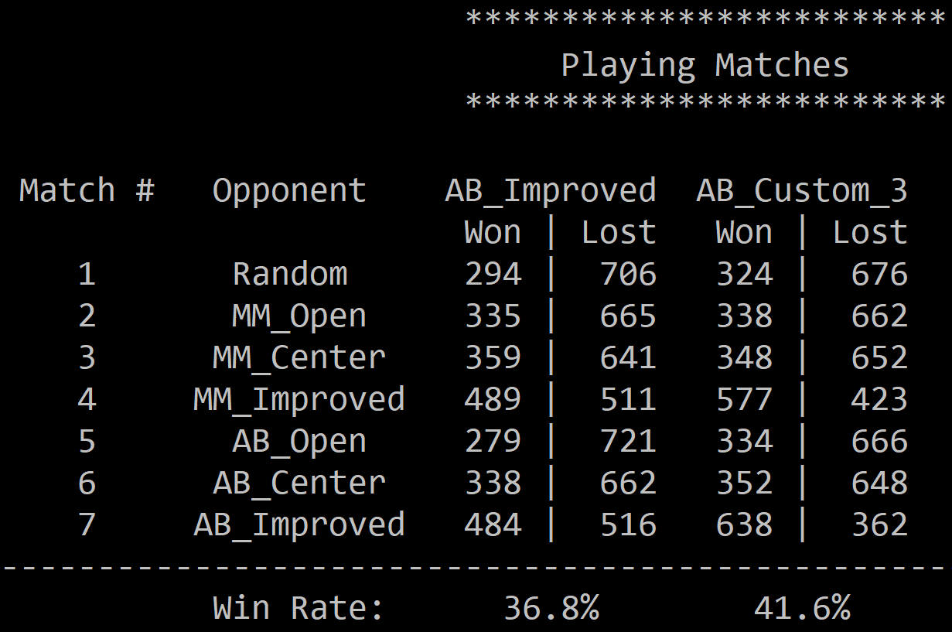

Custom_Score_3 wins roughly 60% of it’s games against AB_Improved, which is a little worse than the roughly 66% that Custom_Score and Custom_Score_2 win.

